BUDO JUNIOR SCHOOL
REMEDIAL WORK FOR TERM 1 2020 - SET TWO
ENGLISH FOR PRIMARY ONE

Name: ____________________________________________________________________
Stream: ________________ Date: ______________________________________

1. Fill in the missing letters.

p___t t___ble
2. Match correctly:
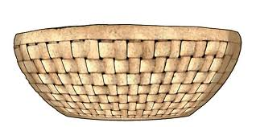 knife
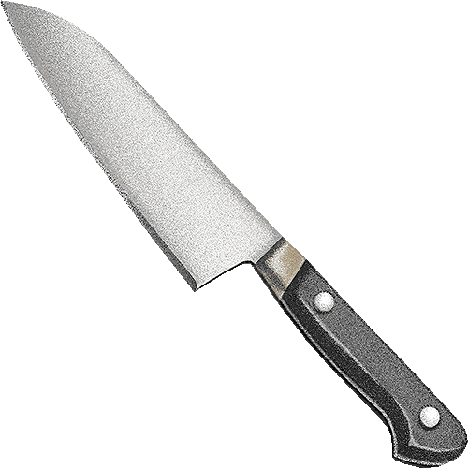 mat

bag
basket

3. Write in small letters.
BOX = box
DUSTER = __________________ BAG = _______________
4. Re-write these words correctly:
yob = boy rchai = ___________ ncilpe = __________

5. Use ‘a’ / ‘an’ to fill the gaps.
_______egg  _____ leaf
Annet has _______ orange.
That is ____ book.

6. Write in plural form.
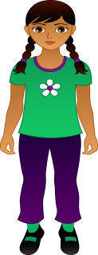 girl - _______________
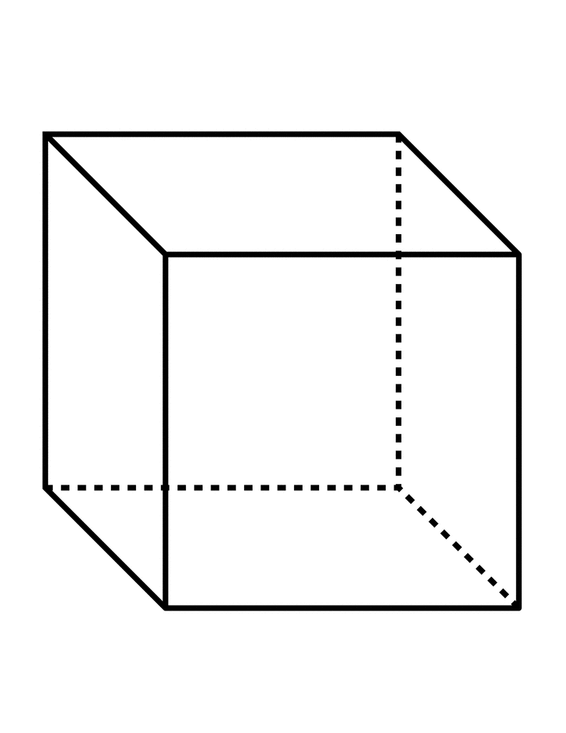 box - _____________
7. Make sentences:
These are chairs.

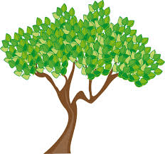 _________________________________
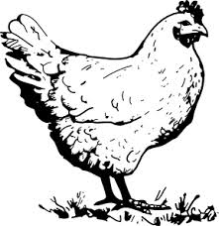 _________________________________
8. How many …… are there?

There are _________houses.
There are ___________ pencils.

9. Use these words to make correct sentences.
are: They are eating mangoes.
is : _________________________________________________
we : ________________________________________________
10. Fill in the correct words.
My name is ________________________________________________.
I am in primary _______. Everyday I go to class, I sit on a
___________ . I put my 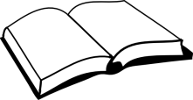_____________

on the _____________ and I use my ______________

to write well. I love my class.

11. Use the correct preposition.
on near between over
 The leaf is ________________ the flowers.
 The cup is ______________ the basket.

The bottle is _______ the box.
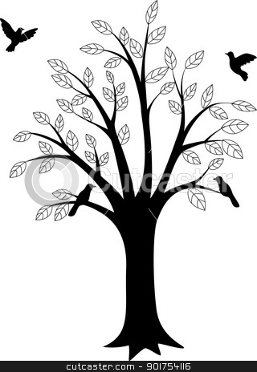 The birds are flying _________the tree.
12. Use these words ; carrying , eating , standing.
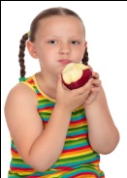 She is ______________ an apple.
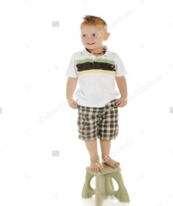 The boy is _________________ on the stool.
 Mary is _________________ a box.
13. Use Yes, they are / No, they are no.
 Are these balls?
__________________________________________
Are these tins?
_________________________________________

14. Rewrite these sentences correctly:
a) primary one I am in.
______________________________________________________
b) a book This is.
______________________________________________________
c) sister my is She.
______________________________________________________

15. Read and draw.
a) A cow has four legs. (b) These are cats.

16. Form words with sound:
ell = bell
b ag = ______________
ox = ______________
ottle = ______________
17. Read the story below.
AT HOME
At our home, father buys foods; mother cooks food and
takes care of the children. The girls wash utensils and the
boys fetch water from the well.

Questions:
1. Who buys food at home?
__________________________________________________________
2. Who cooks food and cares for the children?
__________________________________________________________
3) What do the girls do at home?
__________________________________________________________
4) Draw the boys carrying water from the well.

5) Write one small word from the given words.
father = her
mother = _______ utensils =________

